Use-Case Realization Report (Analysis)
Delete Survey

Issue 1.0
Revision History
Date | Issue | Description | Author
01/Aug/09 | 1.0 | First Issue | Thomas Yap

Table of Contents
1. Brief Description 4
2. Flow of Events 4
2.1 Standard Flow 4
2.1.1 Delete Survey 4
2.2 Exception 4
3. Interaction Diagrams 5
3.1 Collaboration Diagram for Delete Survey 5
4. Participating Objects 5
5. Class Diagrams 6
5.1 Class Diagram for Delete Survey 6
6. Derived Requirements 6

Use-Case Realization Report
Delete Survey

Brief Description
This use case enables the controller to delete survey from Survey Pool. It involves displaying the menu and form for keying in the survey searchstrings or title list to delete the record.

Flow of Events
The standard flow of events for this use case and any exceptions are described in the following subsections. The events are described in terms of Actors and Analysis Objects.

Standard Flow
This use case covers the Survey Maintenance - Delete Survey. The standard flow of these events are described below.

Delete Survey
The running of the application is shown in section 3.1. The flow of event is as follow:

- When the application start, the first operation to be performed is the startup operation of the main controller. This operation will create all the control objects and the entity objects necessary for operation Delete Survey:
  - The control object created is: Survey Controller
  - The entity objects create are: Survey and Transaction Record

- The main controller will start the main function menu:
  - To start Delete SURVEY, operation FormDisplaySURVEY is activated by SURVEY Controller to display a SURVEY form.
  - Portal Admin will select the SURVEY to be deleted then input searchstrings for searching the record. This is done by activating Use Case Display SURVEY Info or Display SURVEY List. Use Case Display SURVEY List will retrieve a title list of SURVEY for Portal Admin to pick to be display on FormDisplaySURVEY.
  - Then SURVEY Controller will check for additional criteria if any.
  - If no record found, SURVEY Controller will send a error message to FormDisplaySURVEY Interface.
  - After the record is found and display on FormDisplaySURVEY, a confirmation request will be sent to the FormDisplaySURVEY interface. Upon confirmation, the record will then be flagged as deleted using operation delete to entity object SURVEY Table.
  - In addition, a transaction log will be created by operation createRecord and store in entity TransactionRecord.
  - A confirmation message will be displayed by FormDisplaySURVEY interface.

- Step 2 will be repeated until all deletions are completion. Then controller will terminate the application by issuing operation close.

Exception
None.

Interaction Diagrams

Collaboration Diagram for Delete Survey
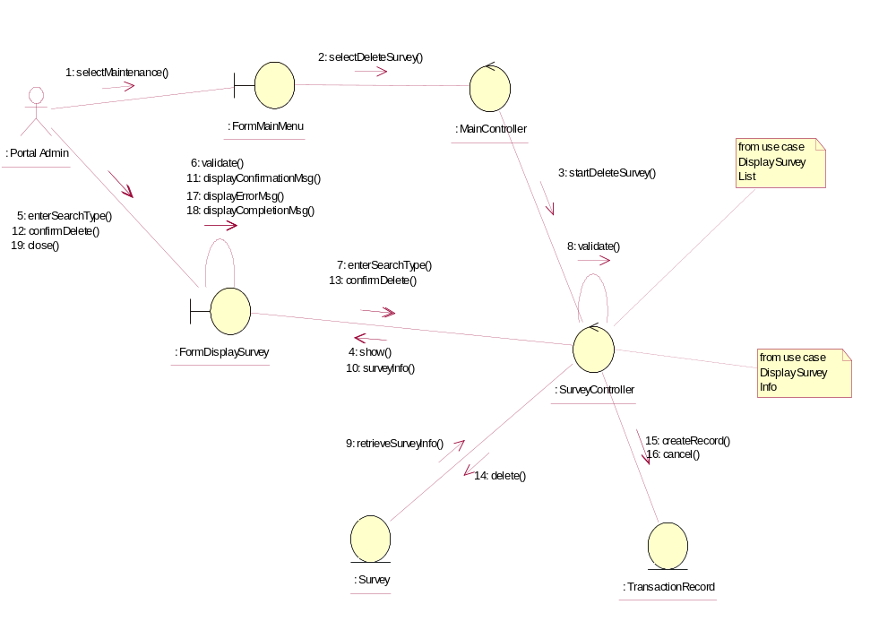

Participating Objects
: FormDisplaySurvey
This object is the interface for keying Surveys details.

: FormMainMenu
This is the main menu at the beginning of the application from where it can access the Survey Maintenance - Delete Survey operation.

: MainController
This is the main controller that control the whole system.

: Portal Admin
This is the only actor that authorized to perform operation Survey Maintenance - Delete Survey.

: Survey
This entity stores all the exam or exercise Surveys.

: SurveyController
This is the controller for Survey Maintenance. It creates and activates FormDisplaySurvey interface and Survey entity object.

: TransactionRecord
This is the entity object that created for transaction log and audit trail.

Class Diagrams

Class Diagram for Delete Survey
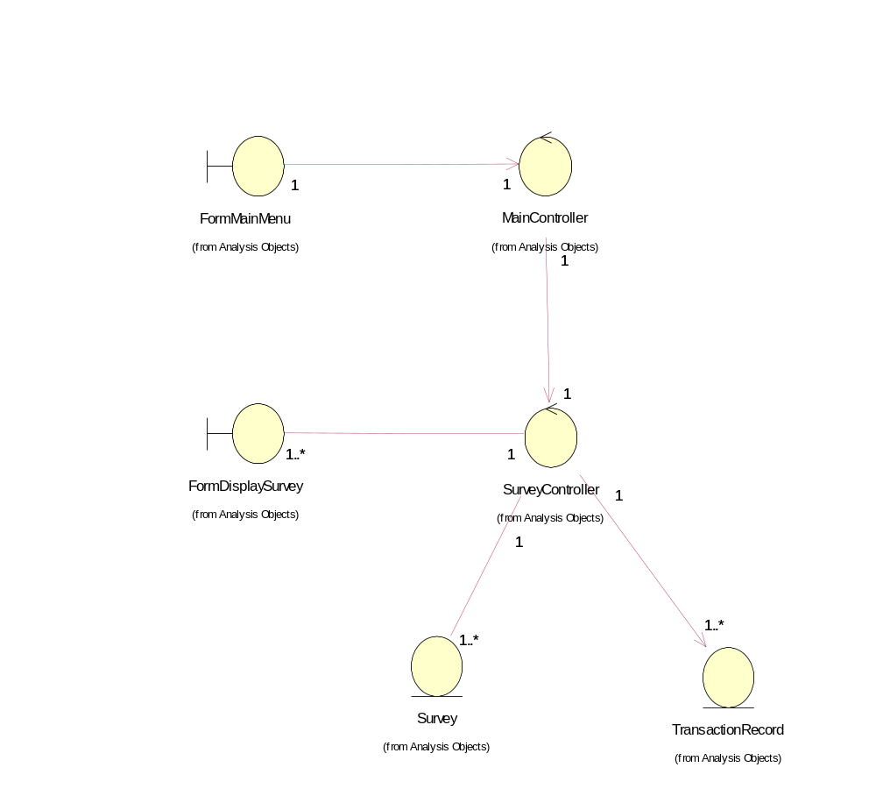

Derived Requirements
The FormMainMenu and FormDisplaySurvey Interface should have the format specified in User Requirements Specification for Content Management Portal.

